Week 25 April - 2 May 2022
World Hand Hygiene Day – 5 May
The SAVE LIVES: Clean Your Hands global campaign, launched in 2009 and celebrated annually on 5 May (World Hand Hygiene Day) aims to maintain global promotion, visibility and sustainability of hand hygiene in health care and to ‘bring people together’ in support of hand hygiene improvement around the world.
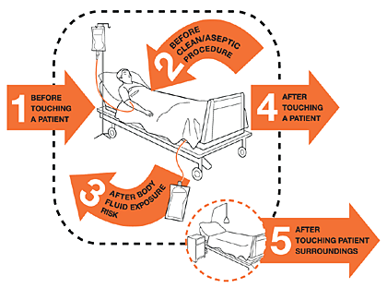 |  | For World Hand Hygiene Day 2022, the World Health Organisation calls on health care workers and facilities to achieve effective hand hygiene action at the point of care. The point of care refers to the place where three elements come together: the patient, the health care worker, and care or treatment involving contact with the patient or their surroundings. To be effective and prevent transmission of infectious microorganisms during health care delivery, hand hygiene should be performed when it is needed (at 5 specific moments) and in the most effective way (by using the right technique with readily available products) at the point of care. This can be achieved by using the WHO multimodal hand hygiene improvement strategy.  https://www.who.int/campaigns/world-hand-hygiene-day/

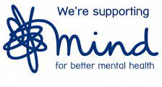 | Stress Awareness Month April comes to an end  MIND shares some tips on how to relax  https://mind.turtl.co/story/mindwork-april-2022/page/2?utm_source=MIND%20(THE%20NATIONAL%20ASSOCIATION%20FOR%20MENTAL%20HEALTH)&utm_medium=email&utm_campaign=13173102_Comms_Mind@work_Apr_29_22_manual_regular_EH&utm_content=Relaxation&dm_i=CZC,7UCFI,1XDR1O,W0H1U,1
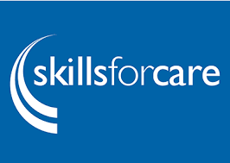 | Skills for Care  Tell us what you think of the learning and development opportunities available for the care sector  It’s important that people working in adult social care have the right skills and knowledge to provide high quality care and support. As the workforce development organisation for adult social care, Skills for Care wants to ensure our learning and development offer continues to support the sector and is responsive to your needs.  Complete our short survey to tell us about the learning and development topics and delivery methods you think are needed to achieve the best outcomes, and how delivery and assessment of the Care Certificate could be improved.
We’d like to hear from all roles across the workforce and your survey response will help us shape impactful future learning and development opportunities and provision. The survey should take less than 25 minutes to complete if you answer all of the questions and closes at 12pm on Monday 16 May 2022.
Fill in the survey https://online1.snapsurveys.com/interview/c8509e3f-77ef-4f1a-af7f-8bd580e54167
For those who want to share more detailed information on their thoughts we’re running some small online events, so come along and have your say. You’ll find more information in the events section of the website.

Date | Topic | Website
25 April | Government Promotional material  10 top tips for parents to support children to read  Short tips for parents of primary-aged children to make reading enjoyable.  Removed references to coronavirus (COVID-19). | https://www.gov.uk/government/publications/10-top-tips-to-encourage-children-to-read?utm_medium=email&utm_campaign=govuk-notifications-topic&utm_source=76702947-120c-43cb-896b-0c6878b423ff&utm_content=daily#full-publication-update-history
26 April | Government guidance  Finding and choosing a private coronavirus (COVID-19) test provider  If you need to purchase a coronavirus (COVID-19) test from a private provider, the following are private test providers. Updated the general list of providers. | Finding and choosing a private coronavirus (COVID-19) test provider - GOV.UK (www.gov.uk)
28 April | Government News story  National flu and COVID-19 surveillance reports published  Weekly national influenza and coronavirus (COVID-19) report, COVID-19 activity, seasonal flu and other seasonal respiratory illnesses. | https://www.gov.uk/government/news/national-flu-and-covid-19-surveillance-reports-published?utm_medium=email&utm_campaign=govuk-notifications-topic&utm_source=961371e3-966d-4260-953c-71d8a337b350&utm_content=daily
28 April | Government Guidance  Using the NHS COVID Pass to demonstrate COVID-19 status  NHS COVID Pass letters for international travel are now available for children aged 5 to 11 living in England, Wales and Isle of Man. | https://www.gov.uk/guidance/nhs-covid-pass?utm_medium=email&utm_campaign=govuk-notifications-topic&utm_source=a18dbd92-77a9-4de1-adfc-1f2262bb4fb1&utm_content=daily#full-publication-update-history
28 April | Government Research and analysis  Coronavirus (COVID-19) vaccines adverse reactions  A weekly report covering adverse reactions to approved COVID-19 vaccines | https://www.gov.uk/government/publications/coronavirus-covid-19-vaccine-adverse-reactions?utm_medium=email&utm_campaign=govuk-notifications-topic&utm_source=a47909c5-2e92-450e-bfcb-9bc3359c1558&utm_content=daily
29 April | Government guidance  The R value and growth rate  The latest reproduction number (R) and growth rate of coronavirus (COVID-19).  The R range for England is 0.7 to 0.9 and the growth rate range for England is -6% to -3% per day as of 29 April 2022. | https://www.gov.uk/guidance/the-r-value-and-growth-rate?utm_medium=email&utm_campaign=govuk-notifications-topic&utm_source=4ae76a7d-20c9-40f6-9307-bcc0cf1c0ce1&utm_content=daily#full-publication-update-history

Date | Topic | Website
April | SCW NHS  South, Central and West (SCW) is an NHS organisation providing support and transformation services to health and care systems.  Are too many people with a learning disability dying earlier than they should be?  Blog | https://www.scwcsu.nhs.uk/news-and-views/blog/learning-disability-mortality-review-leder-programme
April | SCW NHS  What challenges remain for the national childhood immunisation programme  Blog | https://www.scwcsu.nhs.uk/news-and-views/blog/what-challenges-remain-for-the-national-childhood-immunisation-programme

