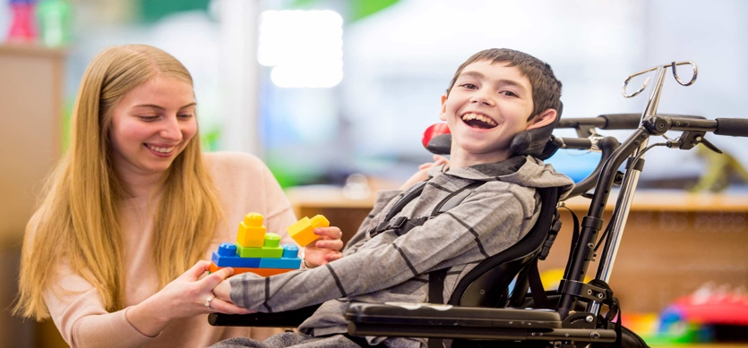

**Cerebral Palsy**

Cerebral Palsy is the name for a group of lifelong conditions that affect muscle tone & coordination. Cerebral Palsy is usually caused by a problem with the brain’s development before, during or soon after birth

**Are there types of Cerebral Palsy?**

There are **3 main types** of Cerebral Palsy, & many people will have a mixture of these 3 types.

***Spastic Cerebral Palsy***

**The muscles are stiff & tight, this reduces a person’s range of movement. Spasticity can be very painful as the muscles are so tight, with muscles going into spasm. This can impact different areas of the body.**

***Dyskinetic Cerebral Palsy***

**The muscles will switch between floppiness & stiffness. This can cause uncontrolled &/or random body movements. The person may find it difficult to control their tongue, breathing & vocal cords. As a result of this, their speech & language may be impacted.**

***(Dyskinetic Cerebral Palsy is sometimes referred to as dystonic, choreoathetoid or athetoid cerebral palsy).***

***Ataxic Cerebral Palsy***

**This is when a person has balance or co-ordination problems resulting in shaky or clumsy movements. Balance & spatial awareness can also be impacted. Due to the inability to activate the correct pattern of muscles during movement, many people will be unsteady on their feet with shaky movements. Ataxia can affect the whole body, but most people with this will be able to walk. Ataxia can impact speech & language too.**

**What causes Cerebral Palsy?**

Cerebral Palsy is usually caused by injury to the baby’s brain either before, during or after birth. Causes of this injury could include a bleed in the brain, reduced blood or oxygen supply to the brain, abnormal brain development, infection during pregnancy, but in many cases the exact cause of cerebral palsy is not clear.

ß

**What are the symptoms of Cerebral Palsy?**

It is unusual to be able to identify cerebral palsy in a baby just after birth; symptoms tend to be more noticeable during the **first 2 to 3 years of a child’s life**.

Symptoms can include:

* Delays in developmental milestones such as not sitting by 8 months, or not walking by 18 months
* Weak legs or arms
* Random uncontrolled movements
* Muscles spasms
* Walking on tiptoes
* Seeming too stiff or too floppy

*The severity of these symptoms can vary. This can depend on the type of Cerebral Palsy an individual has & which parts of the body are most affected.*

People with Cerebral Palsy can also experience other problems such as:

* Problems with speaking & communicating
* Seizures (Epilepsy)

*There is a strong association between cerebral palsy & epilepsy, this is because injury to the brain can increase the chance of abnormal brain activity to occur, which causes epilepsy.*

* Hips that pop or dislocate easily
* Eye problems
* Feeding, drooling, & swallowing difficulties
* A learning disability

**Important Terminology:**

Because Cerebral Palsy can affect different areas of the body, there are different terms used to describe which part of the body has been impacted.

* **Hemiplegia** (1 side of the body affected)
* **Diplegia** (2 limbs affected)
* **Monoplegia** (1 limb affected)
* **Quadriplegia** (4 limbs affected)

ß

One common misconception confuses cerebral palsy as being a learning disability.

**Cerebral palsy is not a learning disability, but some people with cerebral palsy may also have a learning disability.**

**How is Cerebral Palsy diagnosed?**

As Cerebral Palsy usually becomes more noticeable as a child develops, there are several tests that can be done to determine if a child’s symptoms are being caused by cerebral palsy. An assessment of a child’s movements & learning abilities may also be carried out. There may be questions regarding before, during & after pregnancy of the child.

Brain scans can also be used to help diagnose cerebral palsy. A CT scan, MRI, or cranial ultrasound scan can all be used. Other tests can include an EEG (electroencephalogram), EMG (electromyogram) & blood tests can be used to help diagnose cerebral palsy.

**How is it treated?**

There is currently **no cure** for cerebral palsy, but treatments are available to help individuals be as independent as possible. Those with cerebral palsy may need input from healthcare professionals to help manage their condition – this includes the use of a care plan. Treatment will be unique to the individual needs of the person with cerebral palsy, as the severity of the condition will differ in each person.

**Physiotherapy** (also known as Physio) is one of the most important treatments for cerebral palsy. This is because physio can help to increase strength & stop muscles becoming weak. Physio exercises can help to maintain movement. A physio may also recommend using walking aids, or leg braces to support limbs if needed.

A **speech & language therapist** can provide exercises to help with speech or teach alternative methods of communication, for instance sign language.

The therapist may be able to provide specialist equipment such as a computer or device that generates speech. *Techniques taught by a speech & language therapist could also help to improve swallowing problems & drooling.*

An **Occupational therapist** can help to advise individuals the best way to complete activities that involve more complex movements – for instance getting dressed. Occupational therapy can be very beneficial in terms of boosting confidence & self-esteem as it can help an individual to become more independent.

There are **medications** that can be used to help relieve some of the symptoms of cerebral palsy. For example, the use of medication to help with muscle stiffness. In some cases, some individuals with cerebral palsy may need surgery to help with movement difficulties they may be experiencing. This may be able to help restore movement to parts of the body if they are restricted.

**How does it impact daily life?**

Cerebral Palsy will **affect each person differently** depending on the areas of the body most impacted & the severity of symptoms. The amount of support needed on a daily basis will depend on what an individual’s needs are.

The condition can limit activities & independence, but there are many people that **lead full, independent lives**. Many children with cerebral palsy will go to mainstream school, but some may have special educational needs & benefit from attending a specialised school.

**Cerebral Palsy affects about 1 in every 400 children in the UK**

(Scope Website 2022)

**How can I support someone with Cerebral Palsy?**

The daily challenges of living with Cerebral Palsy can be difficult to cope with. It is important to recognise the **emotional impact** a condition may have upon someone aside from the physical strain on the body. Ensure to listen & empathise to the concerns of those who have cerebral palsy, whilst also encouraging them to be independent where they can be.

**Useful Websites**

[**www.nhs.uk/conditions/cerebral-palsy**](http://www.nhs.uk/conditions/cerebral-palsy)

[**www.scope.org.uk/advice-and-support/cerebral-palsy-introduction/**](http://www.scope.org.uk/advice-and-support/cerebral-palsy-introduction/)

**www.mencap.org.uk**