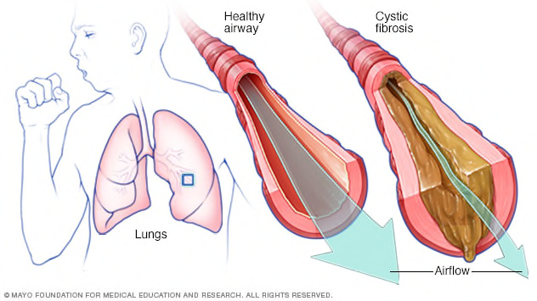

**Cystic Fibrosis**

Cystic Fibrosis is a genetic chronic illness caused by an overproduction of thick sticky mucus. This mucus impacts the whole body but is particularly detrimental to the lungs & digestive system.

**What causes Cystic Fibrosis?**

Cystic Fibrosis is a genetic condition caused by faulty recessive genes. Around **1 in 25** people carry the CF faulty gene (2 copies of which result in someone having CF). This means that if 2 people are carriers of this gene, there is a 1 in 4 chance that their child will be born with Cystic Fibrosis.

There are **over 2,000** identified mutations of the CF gene. CF is a very complex condition which affects each person in different ways. This means that some people suffer more with their digestive system than their lungs. Whereas others will have few problems with their digestive system.

**What is Cystic Fibrosis?**

Cystic Fibrosis (CF) is a genetic illness. People with CF produce a lot **thicker mucus** than is normal. In the lungs, this causes bacteria to be trapped in the small airways which leads to infection. Over time these regular infections cause **permanent damage & deterioration to the lungs.**

In the digestive system, thickened mucus can block the flow of digestive juices & prevent food from being digested properly. As a result of this, many people with CF will experience **issues with digestion**, growth, &/or have **pancreatic insufficiency**.

ß

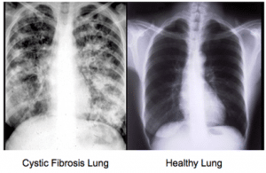

**What are the symptoms of Cystic Fibrosis?**

*Symptoms of Cystic Fibrosis can include:*

* **Regular chest infections**
* **Persistent cough**
* **Wheezy or tight airways**
* **Breathlessness**
* **Difficulty putting on weight**
* **Fatigue**
* **Constipation**
* **Diarrhoea**

People with CF can also develop related conditions such as CF Related diabetes (CFRD), CF related Arthritis, sinus problems, osteoporosis, problems with the liver, kidneys & bowels.

Due to the sticky mucus in the bowel, constipation is common in those with CF. This puts people with Cystic Fibrosis at a **5 to 10 times greater risk** of colon cancer compared to the general population.

**Cystic Fibrosis Lungs vs Healthy Lungs**

**How is it diagnosed?**

All new-born babies are tested for CF shortly after birth using the **heel prick blood test.** This tests for the most common mutations of the CF gene. If the screening suggests a child may have CF, further tests such as a sweat test or genetic test can also be carried out to diagnose Cystic Fibrosis.

**How is it treated?**

People with CF need to complete a **rigorous daily regime** of treatments in order to stay healthy. This can include many types of antibiotics, vitamins, pancreatic enzymes, inhaled medications, nebulised drugs & daily physiotherapy sessions all to help manage the condition.

Due to regular chest infections, people with CF are often on prolonged courses of antibiotics. This is often needed in the form of **intravenous antibiotics** – which are often administered as a 2 weeklong course in hospital.

There is currently no cure for Cystic Fibrosis, but there are new drugs being developed that help target many of the symptoms. These ‘modulator’ drugs can help to better **manage the symptoms** of CF such as mucus production & lung infection. But they are not yet accessible to everyone with CF & can cause severe side effects for some.

Some people with CF may need a transplant for an organ affected by CF – but this process does not come without its own risks & complications.

**How can I support someone with Cystic Fibrosis?**

Any chronic illness or disability can feel isolating, but people with Cystic Fibrosis may feel this more intensely than others. This is because people with CF cannot mix with each other due to the **risk of cross infection in the lungs.** This can make the illness extremely difficult to deal with, as CF patients are unable to make real life connections with others with their illness. Being mindful of this can help those with CF to feel less alone.

Those with CF are at **greater risk** of mental health conditions such as anxiety & depression, therefore it is equally as important to check in on someone’s mental health as it is their physical health! Having a chronic illness can take an emotional toll, so it is important to **listen & empathise** with those who have Cystic Fibrosis.

**Around 10,600 people in the UK have CF.**

**Around 100,000 people are affected by Cystic Fibrosis worldwide**

(Cystic Fibrosis Trust UK Website 2022)

**How does it impact daily life?**

People with Cystic Fibrosis can lead full happy lives, especially as advancements in medication means that people with CF are living longer.

CF is a **progressive illness**, meaning that it tends to get worse with time, which is why regular medication & input from doctors & a medical team are so important in managing the condition.

According to a recent report, **half of the people born with CF in 2017 would live to at least 47** (Cystic Fibrosis Trust UK). The exact figures for life expectancy differ from different sources & are dependent on individual health. But the average life expectancy for people with Cystic Fibrosis has significantly increased over the last decade.

**Useful Websites**

**www.nhs.uk/conditions/cystic-fibrosis/**

**www.cysticfibrosis.org.uk**