**Dystonia**

Dystonia is a neurological movement disorder caused by incorrect signals from the brain. This results in uncontrollable & sometimes painful muscles movements (also known as spasms)

**Are there types of Dystonia?**

There are **many different types of dystonia.** Neck & eye dystonia are two of the most common types of dystonia. Dystonia can also affect multiple or singular parts of the body.

*Some important terminology for different types of dystonia include:*

**Generalised dystonia** – affects most or all of the body

**Focal dystonia** – affects one part of the body

**Multifocal dystonia** – affects two or more unrelated parts of the body

**Segmental dystonia** – affects two or more adjacent parts of the body

Dystonia may also be referred to as ‘primary’ or ‘isolated’. This means dystonia is the only neurological symptom an individual appears to have. Despite dystonia being able to present at any age, if it starts in adult life, the dystonia will usually remain to just one or two parts of the body. Dystonia that starts in childhood tends to spread across multiple areas of the body.

**What causes Dystonia?**

The cause of dystonia is **not yet fully understood,** & often the cause of why someone may have dystonia is unknown. In some cases, it is thought to be caused by a **chemical imbalance** in a part of the brain called the **basal ganglia** (which helps to control movement).

*This chemical imbalance can be:*

**Inherited** – a dystonia caused by mutations in a specific gene

**Acquired** – a dystonia that appears to have specific cause such as a drug reaction, brain injury, or as a symptom of another neurological/metabolic disorder

**Idiopathic** – a dystonic with no known or identifiable cause

ß

**What are the symptoms of Dystonia?**

Dystonia is a **lifelong condition** that can present itself at any age. Dystonia can also impact **any region of the body.**

Symptoms of dystonia include:

* Uncontrolled muscle cramps or spasms (which can be painful)
* Shaking (or tremors)
* Uncontrolled blinking
* Parts of the body twisting into unusual positions such as inwards turning feet, or the neck being twisted to one side

The symptoms of dystonia can come & go but can also be continuous in nature. Symptoms can be impacted by factors such as stress, but other activities could include drinking alcohol/caffeine, being tired, or talking, eating or chewing.

In the majority of those who live with dystonia, it does not impact life expectancy. But in very severe generalised dystonia, (where multiple parts of the body are impacted) there may be problems that arise secondary to dystonia that could cause life threatening conditions.

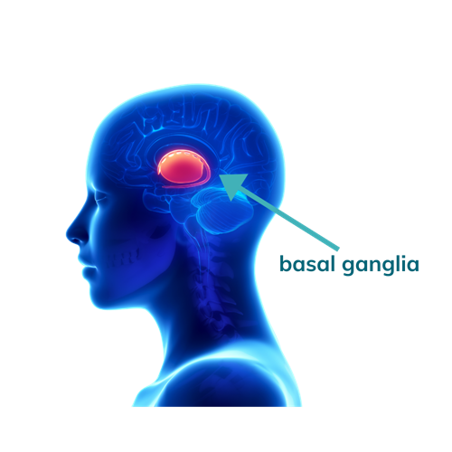

**How is Dystonia diagnosed?**

If a doctor suspects someone may have dystonia, they may be **referred to a neurologist** for further tests. In order to diagnose someone with dystonia, a neurologist may ask questions about an individual’s symptoms, general health, & enquire if anyone else in the family has dystonia (as it can sometimes be inherited).

Blood & urine tests can also help to diagnose dystonia, along with brain scans to try & identify any problems.

**How does it impact daily life?**

The symptoms of dystonia can vary in severity, so **different people with the condition will be affected in different ways**. Dystonia can make daily activities painful & difficult. Someone with dystonia may notice periods of time where their symptoms are worse, & the condition ‘flares up’, & others where symptoms remain steady.

**How is it treated?**

There is currently **no cure for dystonia**, however there are treatments that can help to manage the symptoms of the condition.

Some common treatments include:

* Injections of a type of medicine called **botulinum toxin**. This is injected directly into affected muscles & needs to be repeated approximately every 3 months.
* Medicine that can help to relax muscles in a larger part of the body – this can be given as tablets or injections into a vein.
* Oral medication, such as **Levodopa,** to help manage symptoms
* **Physiotherapy**, as this can help to strengthen muscles, & help those who may have problems with walking
* A type or surgery called **deep brain stimulation.** This involves inserting a small device under the skin of someone’s tummy or chest. This device sends targeted electrical signals along wires placed in the part of the brain that controls movement. **This can block the signals coming from the brain that cause dystonia.**

*This kind of treatment option is usually offered to those who have severe generalised dystonia, or when other treatment methods have failed to provide relief of symptoms.*

**Dystonia is estimated to affect at least 100,000 people in the UK**

(Dystonia UK Website 2022)

**How can I support someone with Dystonia?**

People with dystonia **can lead full happy lives**, but it is important to recognise how any condition may impact someone. It can be very frustrating feeling like you have little control over your body. It can also be draining both physically & mentally having to manage & deal with regular pain & muscles cramps. It is important to **listen & empathise** with someone’s concerns to make them feel supported. People with dystonia need to be able to be independent, whilst also being supported if/where they need it.

**Useful Websites**

**www.dystonia.org.uk**

**www.nhs.uk/conditions/dystonia/**