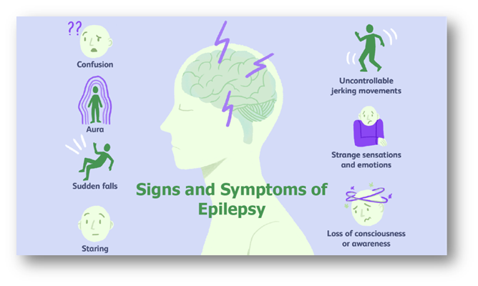

**E p i l e p s y**

Epilepsy is a common neurological condition which affects the brain & nervous system. People with Epilepsy experience abnormal electrical activity in the brain which causes seizures (also known as convulsions).

**How is epilepsy diagnosed?**

If there is a possibility that someone has epilepsy, there are many tests that can be undertaken to try & understand what could be **causing** someone’s seizures. This could include, an Electroencephalogram (EEG), blood tests, brain & MRI scans. It is also important for a doctor to understand what has happened **before, during & after someone has experienced a seizure.** All of these measures can be utilised to help diagnose someone with epilepsy.

**What are epileptic seizures?**

Anyone can experience a one-off seizure as a result of an acute health event (such as a head injury or raised temperature during infancy), but when someone is diagnosed with epilepsy, this means that they have an increased risk of seizures presenting.

A seizure occurs when there is a burst of **intense electrical activity** in the brain. This causes a temporary disruption in the way the brain normally functions, resulting in an epileptic seizure.

There are **different types** of seizures, such as a partial or generalised seizures - smaller or larger areas of the brain can be impacted during a seizure. This will also affect the signs & symptoms that present. For instance, someone could lose consciousness, notice unusual sensations, or fall to the floor & convulse whilst having a seizure. In contrast someone could remain conscious, alert & aware of their surroundings during a different type of seizure.

**How is it treated?**

Epilepsy **cannot be ‘cured’** but for many people their seizures can be controlled or stopped through treatment. Many people will take medication called **anticonvulsants** to help control their seizures.

If medication is not effective in the management of seizures, **other types of treatment may be considered.** This may include, brain surgery, the surgical implantation of a vagal nerve or deep brain stimulator, or a ketogenic diet (this tends to be suggested when other methods have been unsuccessful).

**There are 600,000 people with epilepsy living in the UK. Epilepsy affects around 1 in every 100 people**

(Epilepsy Action Website 2022)

**How does it impact daily life?**

Epilepsy is usually a lifelong condition, but it can become more manageable over time. With the use of medication, dietary changes & electrical devices, many people are able to **live normal lives** when their seizures are well managed.

Many children with epilepsy are able to go to a mainstream school & take part in most activities & sports.

However, someone with epilepsy may have to consider the risks of certain activities, such as driving, swimming, taking baths, certain jobs, using contraception & planning a pregnancy.

**How does someone get epilepsy?**

In many cases, it is not clear why the sudden bursts of electricity, which cause epileptic seizures, happen in the brain. It is possible that there is a genetic component impacting how the brain works; **1 in 3 people diagnosed with epilepsy will also have a family member with it.**

In rare cases epilepsy can also be caused by **damage to the brain**. For example, a stroke, severe head injury, brain tumour, drug abuse, or brain infection could all cause damage to the brain, resulting in the onset of epilepsy.

***Epilepsy can start at any age but is most commonly diagnosed during childhood & in people over 60.***

**How can I support someone with Epilepsy?**

Although many people diagnosed with epilepsy will be able to effectively manage their condition on their own, it is still important that all of us can recognise **how to support someone, should a seizure present.**

Aside from the physical symptoms of epilepsy, **seizures can be very frightening for the individual**, particularly when they present suddenly. Not being able to predict when a seizure may happen could make the individual living with epilepsy anxious or hesitant to do certain things. With consideration to this it is important to **listen & empathise** with those who live with epilepsy. Whilst also encouraging & supporting them to engage with activities they want to participate in.

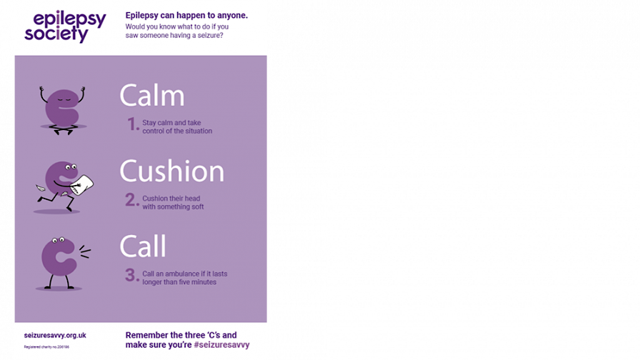

**How do I know if someone is having a seizure?**

Seizures can be significant in their presentation or more subtle. This can be across the systems of the body, **one or more systems can be impacted by a seizure.**

For example, a **Tonic-Clonic seizure** affects an individual’s motor system. This could present through the body going stiff, the individual **falling to the floor, losing consciousness & beginning to convulse.** Due to irregular breathing the individual may go pale, they may also lose control of their bowel/bladder functions or bite the inside of their mouth during this kind of seizure.

**The Do’s & Don’ts of how to help someone having a seizure**

**D o :**

* Make sure the area is safe to approach
* Move any harmful objects away from them
* **Cushion their head**
* Check for some kind of epilepsy identification card/jewellery as it may give you information about their seizures
* Time how long the seizure lasts
* **Follow their seizure plan**

*For those who are not diagnosed with epilepsy, or have never had a seizure before, call an ambulance immediately*

* Once convulsions have stopped put them in the recovery position to support their airway
* **Stay with them**
* Be reassuring, maintaining gentle tone of voice & therapeutic touch

**D o n ’ t:**

* **Don’t move them** unless they are in danger
* Don’t give them anything to eat or drink until they are fully recovered
* **Don’t restrain them**
* Don’t try to bring them round

**Useful Websites**

**www.epilepsy.org.uk**

[**www.epilepsysociety.org.uk**](http://www.epilepsysociety.org.uk)

**www.youngepilepsy.org.uk**