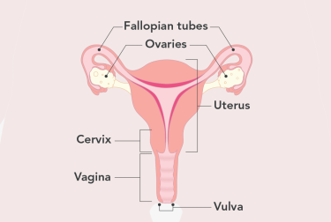

**The Menopause**

The menopause is a process that happens when an individual’s periods stop. This is due to lower hormone levels & usually happens between the ages of 45 – 55

**Menopause Month 2022**

The purpose of menopause month is to help women understand the possible health issues associated when approaching, during, & after the menopause. The World Health organisation & the International Menopause Society designated October as World Menopause Month 2022

**What are the symptoms? -** An Overview

Both the menopause & perimenopause can cause symptoms such **as mood swings, anxiety, hot flushes, brain fog & irregular periods.** These symptoms can start years before a person’s period stops & continue afterwards too. Symptoms of the menopause & perimenopause can have a big impact upon one’s life, including personal relationships & work. There are things that can be done to help these symptoms. There are even medicines that can replace missing hormones & help to relieve symptoms.

**What is the Menopause?**

Despite the menopause tending to occur between the ages of **45 – 55** for some, the menopause can happen earlier than this. This could be due to surgeries, such as a hysterectomy where the uterus is removed, or an oophorectomy where the ovaries are removed. Other causes could include genetic factors & cancer treatments such as chemotherapy.

**Perimenopause** is when symptoms of the menopause happen before periods have actually stopped. A person reaches the menopause when they have not had a period for **12 months.**

ß

**Symptoms of the Menopause**

Symptoms of the menopause can feel different to everyone who experiences it. For instance, some people may not notice any symptoms, whereas others experience multiple. The first sign of the perimenopause is usually a recognisable by a **change in normal pattern of periods,**

for instance, they start to become irregular.

**Mental Health Symptoms**

- Changes in mood

- Mood swings

- Teariness

- Low self-esteem

- Problems with memory or concentration

(also known as brain fog)

**Physical Symptoms**

- Hot flushes; sudden feelings of hot or cold in your face, neck & chest which can make you feel dizzy

- Difficulty sleeping (this may also include / be a result of night sweats). This lack of sleep can negatively impact mood & increase feelings of fatigue & irritability throughout the day

- Migraines

- Headaches

- Heart palpitations

- Joint pains & muscles aches

- Changes to the skin including dryness & itching

- Weight gain & changes in body shape

- Reduced sex drive

- Vaginal dryness

- Discomfort pain / itching during sex

- Urinary tract infections

**Relieving symptoms**

Symptoms can last for months, years, & can change with time. *For instance, sleep & night sweats may improve, but low moods may become more frequent.* It is important to remember that the perimenopause & menopause will impact everyone differently, including the amount & severity of symptoms. Eating well, exercising, & looking after your mental wellbeing can all help to relieve symptoms of the menopause.

**Do …**

**- Eat a healthy & balanced diet**

**- Eat calcium rich food such as milk, yoghurt & kale to keep bones healthy!**

**- Get plenty of rest (this includes trying to stick to a regular sleep routine)**

**- Make sure to do regular exercise e.g. activities where your feet support your weight, such as running, walking, dancing, going to the gym**

**- Make sure to take time for yourself to relax – this could involve yoga or meditating**

**- Talk to people who are going through the same thing, such as friends, family, colleagues**

**- If you feel you are struggling with your symptoms, make sure to talk to a doctor who may be able to suggest some medication options**

**Don’t …**

**- Don’t smoke**

**- Don’t drink excessive amounts of alcohol (no more than the recommended alcohol limit)**

**Managing symptoms**

**To help ease mood swings, plenty of rest, regular exercise, & relaxing activities can all help to manage changes in mood.**

To help with hot flushes & night sweats, make sure to wear lighter clothing, make sure to keep your bedroom cool at night, take a cold shower, have a cold drink or use a fan. Make sure to exercise regularly, lose weight if you are overweight, & try to reduce stress levels where possible.

Avoiding or reducing potential triggers such as a spicy food, caffeine, hot drinks, alcohol & smoking can help to lessen or prevent the effects of hot flushes & night sweats.

To help with vaginal dryness, vaginal moisturisers or lubricants can be purchased over the counter without a prescription. You can also talk to a doctor or pharmacist in private for help & advice.

If you are having sex using condoms, make sure to always used a water-based lubricant so not to damage the condoms.

To help protect against weak bones & osteoporosis, make sure to follow recommended **‘do’s’ referenced above**, such as, regular exercise, eating a healthy balanced diet, stop smoking & cut down alcohol, & make sure to get enough vitamin D as this helps to keep your bones healthy.

**Treatment**

The main medicine used for treatment of the perimenopause & menopause is HRT, Hormone replacement therapy, which replaces the hormones that are at low levels. HRT uses Oestrogen to replace your body’s own levels around the time of the menopause. There are different types of doses of HRT, but using the right dose usually helps to improve someone’s symptoms.

Some non-hormone medicines can help for night sweats & hot flushes, (such as an epilepsy medication called gabapentin & a blood pressure medicine called clonidine).

Cognitive behavioural therapy (CBT) can also help when it comes to emotional support & can help with low mood & anxiety. ***For more information about treatments for the menopause please visit the NHS website under ‘Menopause’.***

**Sexism surrounding the menopause**

Historically the menopause has been seen as an end to a stage of life, often causing older women to become marginalized. Because our societal beauty standards idolise youth & fertility in women, this only feeds into the negative connotations surrounding menopause & ageing in women. But the ageing process is such an important life phase for everyone - & the menopause is a crucial part of this.

The menopause can be difficult to go through, but should not be deemed as an awful or shameful thing to experience. The menopause should not be seen as a condition needing treatment but rather for what it is; a natural stage of life.

**Help & Support**

The perimenopause & menopause can be an isolating process to go through. This is why it is so important for those going through it to feel supported, both in their symptoms & in any concerns they may have.

**Make sure to speak to a health care professional if you need any advice, help or support with your symptoms.**

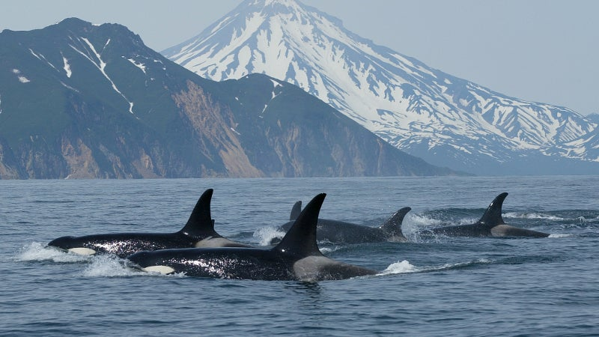

**Useful Charities**

**Some charities listed below maybe of comfort to those experiencing the menopause. Many of these charities have social media pages; their posts & information have helped to raise awareness & create an online community of those who are experiencing the menopause together.**

**These charities include:**

* **Women’s Health Concern**
* **Menopause Matters -@menopausematters**
* **Queermenopause – for those who identify as LGBTQ+**
* **Daisy Network – for those going through a premature menopause - @thedaisynetwork**
* **Menopause Café**

**It’s not just humans …**

Although it is rare amongst mammals, it’s not just humans who experience the menopause – killer whales (Orca), pilot whales, beluga & narwhals also lose the ability to reproduce with age. The menopause is thought to help children’s offspring to survive, as by older females forfeiting their chance to reproduce, they can use this time & energy to nurture their children’s children.