August 2025
 |  | Fair pay in social care is a fine and progressive policy – but who is going to pay for it? If there is no such thing as a free lunch, there is definitely no such thing as a free pay rise. That unavoidable truth is at the heart of unease within the social care sector about the government’s planned ‘fair pay agreement’ for care workers, an unease that is
exacerbated by the total lack of certainty about what any agreement will cover, how it will be negotiated, when it will happen, what will be its impact, what it will cost – and who will pay the bill. Fair Pay In Social Care Is A Fine And Progressive Policy – But Who Is Going To Pay For It? | The King's Fund
 | What impact do strikes have on the NHS? Labour disputes are not new – either to the UK or the NHS. But my goodness, they used to be rare. Fifty years ago, both consultants and resident doctors (formerly known as ‘junior doctors’) withdrew non-emergency services during the 1975 doctors’ strikes.
It would be forty years until the next national walkout of resident doctors in 2016. But since 2022, strikes by different NHS staff groups have become an increasingly familiar feature of our lives. And with that familiarity there’s a risk that we become inured to their impact. Here, then, is an updated reminder of the different ways in which strikes can affect the NHS and the people it serves. What Impact Do Strikes Have On The NHS? | The King's Fund
 | Do we really understand what a healthy weight looks like for all ethnicities? Population health and prevention are top of the agenda for the and the NHS. To understand whether progress is being made, we need benchmarks for health that can track health across the diversity of our population.
Do We Really Understand What A Healthy Weight Looks Like For All Ethnicities? | The King's Fund
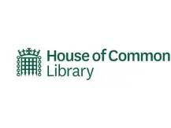 |  | House of Commons Library – NHS Winter preparedness Winter remains a critical stress point for the NHS in England, especially for accident and emergency and ambulance services. This briefing looks at some of the reasons there are additional pressures on the NHS during the winter, and how the NHS in England seeks to address this, ensuring hospitals can cope through the colder months. It focusses on some of the pressures identified in winter 2024/25, and the plans for the NHS in England to prepare for winter 2025/26. NHS winter preparedness - House of Commons Library
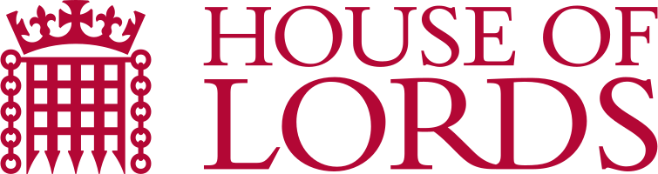 |  | House of Lords Library - Terminally Ill Adults (End of Life) Bill This briefing gives an overview of the proposed The Terminally Ill Adults (End of Life) Bill. The bill would allow adults in England and Wales with a prognosis of less than six months to live to be provided with assistance to end their lives, subject to eligibility criteria and conditions. House of Lords Gold Logo - Search Images
 |  | House of Commons Library - Mental Health Bill [HL] 2024-25: progress of the bill This briefing provides an overview of the progress of the bill through the House of Commons prior to report stage. The bill would amend the Mental Health Act 1983 to strengthen the patient voice, increase scrutiny of detention and to limit how the act is used to detail autistic people and people with a learning disability. The briefing provides a summary of themes from the second reading of the bill and amendments at the Commons committee stage. Mental Health Bill [HL] 2024-25: progress of the bill - House of Commons Library
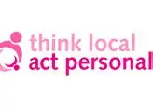 |  | Think Local Act Personal - 'I just want to be able to dance' This report explores how people living with dementia can maintain their wellbeing and how place-based community development and social innovation can grow and sustain the conditions, resources and support that will allow more people to do so in future. Based on conversations with people living with dementia, family and friend carers, academics and people who work in care and support, it presents a vision for what’s possible, alongside nine practical actions to guide the way forward. ‘I just want to be able to dance’ - TLAP

Infection Prevention guidance and updates
04/08/25 | UK Health Security Agency News story  Public advised to stop using certain non-sterile alcohol-free wipes  Due to risk of infection, non-sterile alcohol-free wipes are not appropriate for the treatment of injuries, wounds or on broken skin, nor for cleaning of intravenous lines. | Public advised to stop using certain non-sterile alcohol-free wipes - GOV.UK
21/08/25 | UK Health Security Agency Guidance  Flu vaccines: 2025 to 2026 flu season  Flu vaccines available for the 2025 to 2026 flu season and the clinical risk groups that they apply to.  Updated for 2025 to 26 season.  Eligible groups for the 2025 to 2026 season:  - aged 2 and 3 years on 31 August 2025  - eligible school-aged children (Reception to Year 11)  - those aged 6 months to under 65 years in clinical risk groups  - pregnant women  - all those aged 65 years and over  - those in long-stay residential care homes  - carers in receipt of carer’s allowance or main carer of an older or disabled person  - household contacts of immunocompromised individuals  - frontline health and social care staff | Flu vaccines: 2025 to 2026 flu season - GOV.UK

Other Topics - updates
01/08/25 | Driver and Vehicle Licensing Agency Guidance update  Information on driving licences (INS57P)  Guidance on driving licences.  PDF leaflet updated | Information on driving licences (INS57P) - GOV.UK  INS57P Information on driving licences
07/08/25 | UK Health Security Agency Collection – new publication  Environmental Exposures  Discover more about airborne allergens, air quality, water quality and other environmental exposures such as chemicals and radiation. These pages are under development and some topics are not yet available. | Environmental Exposures - GOV.UK  Airborne allergens - a quick guide - GOV.UK  Prevention and coping with allergen symptoms - GOV.UK  Respiratory conditions caused by airborne allergens - GOV.UK
07/08/25 | UK Health Security Agency News story  UKHSA issues warning over botulism  UKHSA warns public to be alert to botulism following adverse reactions to cosmetic procedures involving botulinum toxin. | UKHSA issues warning over botulism - GOV.UK
08/08/25 | Department for Transport Guidance  Using a Blue Badge in Europe  Using a UK Blue Badge parking card in the EU and EEA.  Update: UK Blue Badge recognised in France. | Using a Blue Badge in Europe - GOV.UK
12 /08/25 | Office for Product Safety and Standards New Guidance  Child safety: small hazards, big harm  OPSS is leading a fresh campaign to raise awareness among parents and carers about the potential dangers to children from swallowing small objects.  Contents  - Small hazards, big harm: button batteries  - Small hazards, big harm: magnets  - Small hazards, big harm: small objects | Child safety: small hazards, big harm - GOV.UK

Other Topics - updates
14/08/25 | Disclosure & Barring Service Guidance update  Basic DBS check: guidance for applicants  Guidance for applicants on basic DBS checks, including the cost, how to share and view the result, and what information is disclosed on a basic DBS certificate.  Contact details updated | Basic DBS check: guidance for applicants - GOV.UK
23/08/25 | Department for Transport Guidance  £3 national bus fare cap  A list of bus companies and bus routes included in the £3 bus fare cap scheme.  Updated list of bus routes. | £3 national bus fare cap - GOV.UK

